ACTIVITIES
Inauguration of Departmental Wall Magazine
2022-05-21

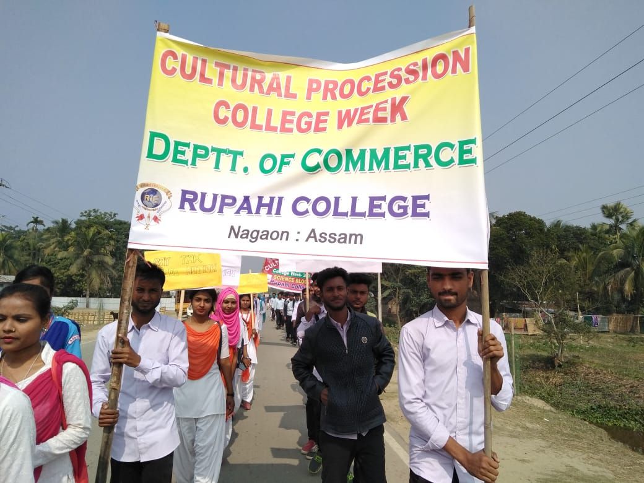
Cultural Rally on College week
2022-02-19

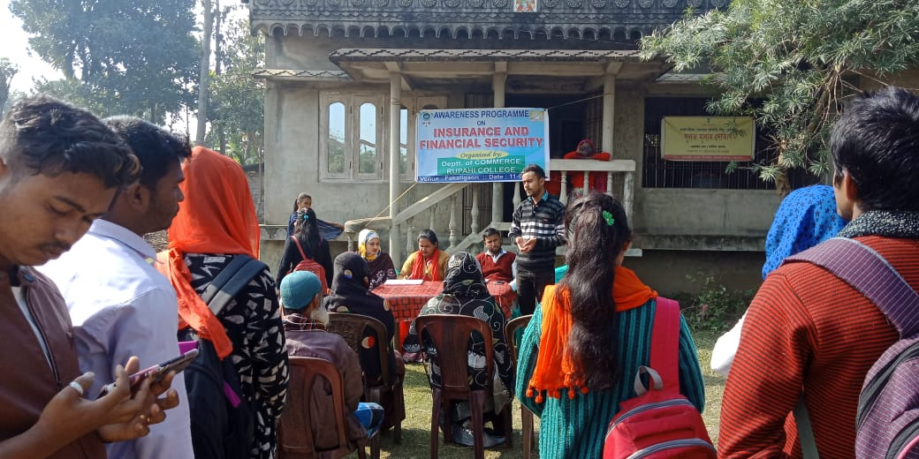
Awareness Program on ‘Insurance and financial security’
2021-01-11

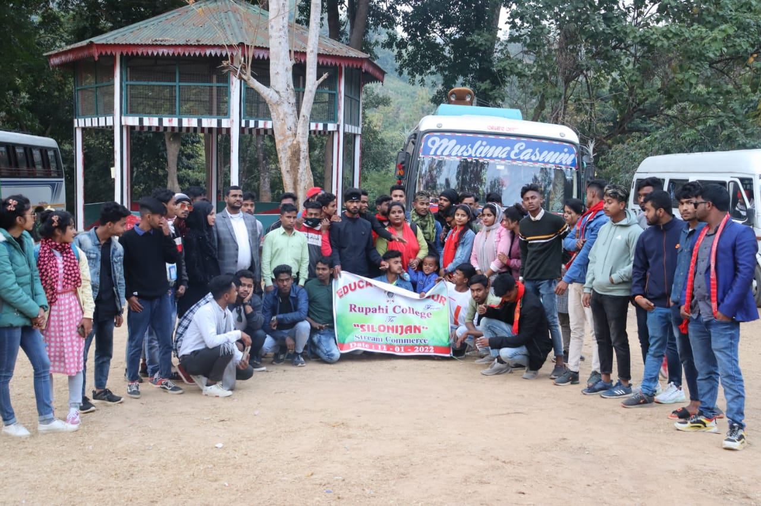
Educational tour to Silonijan
2022-01-11

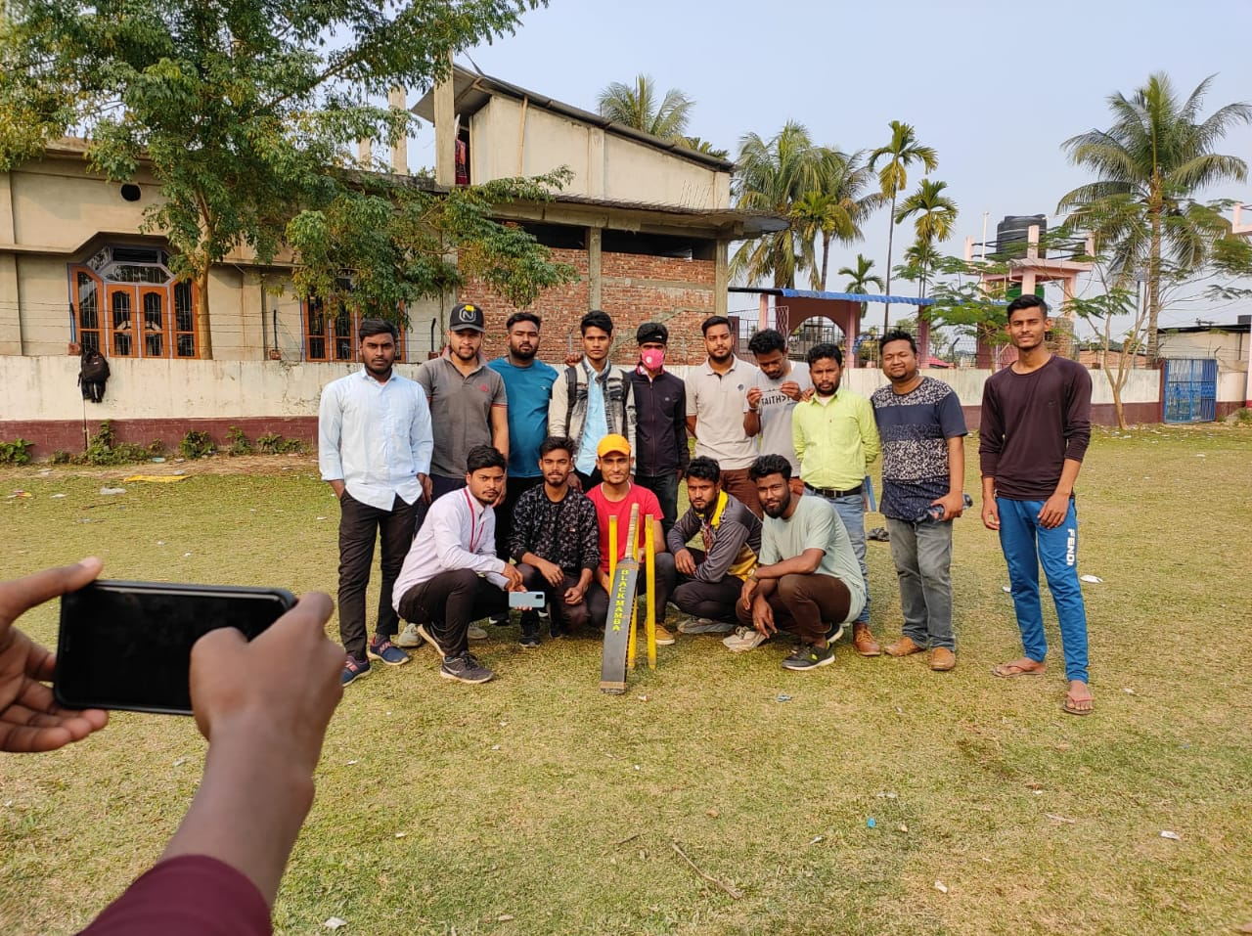
Intra College Cricket Competition
Science V/S Commerce

