DEPARTMENTAL ACTIVITY

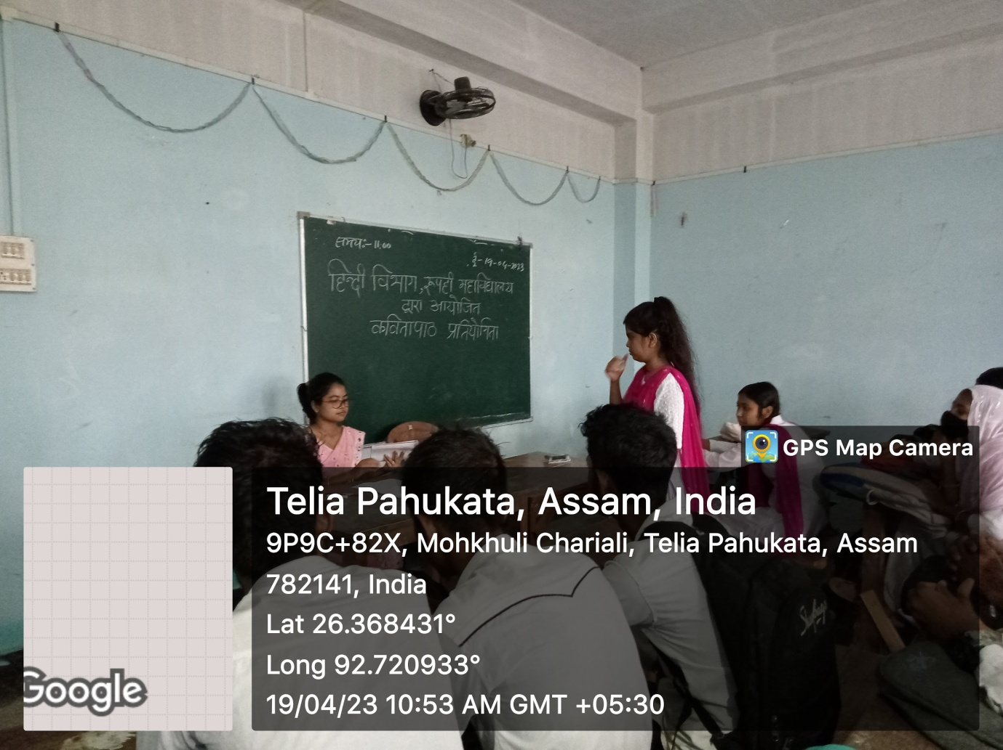

Poetry Recitation (Kavya Paath Pratiyogita)
19-04-23

2.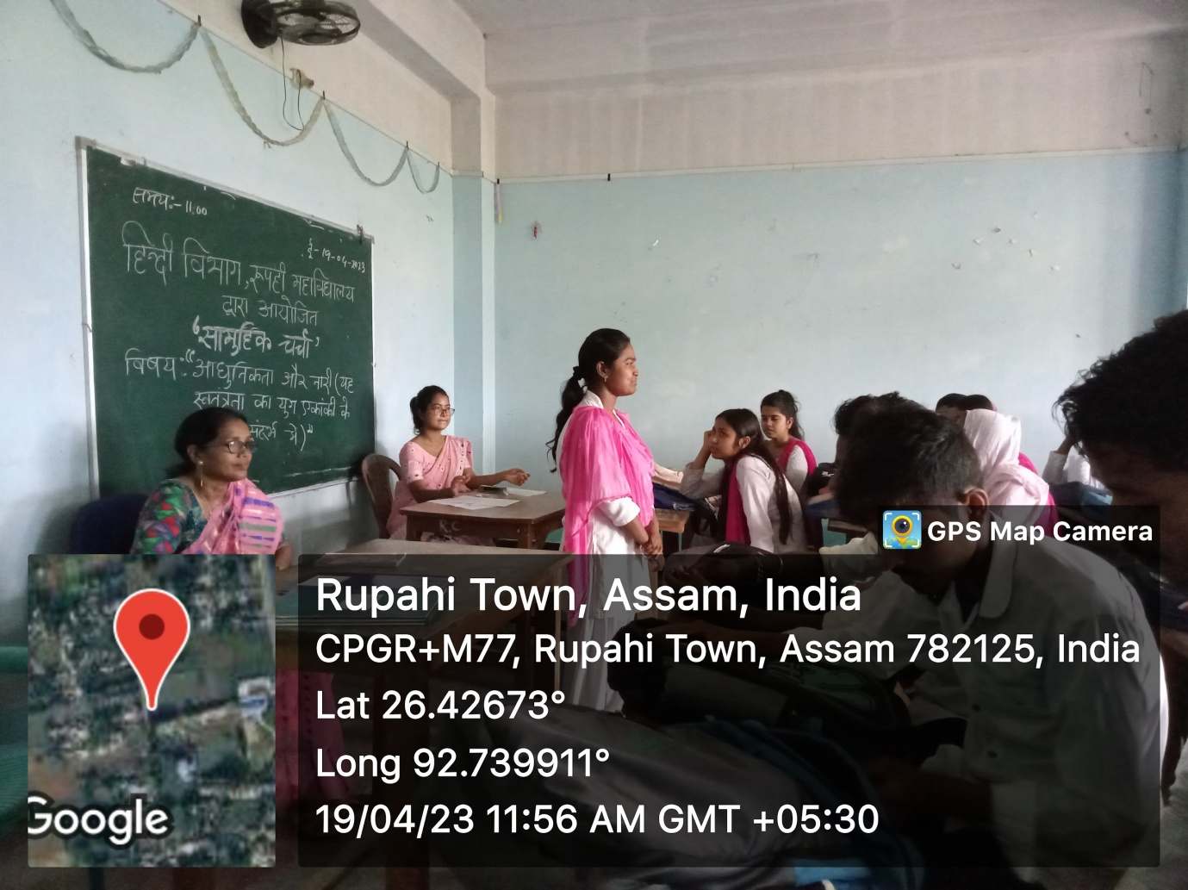

Departmental Students Discussion (Samuhik Charcha)
On
"Aadhunikta aur Naari: Yeh Swatantrata ka yug Ekanki ke vishesh sandarbh mein'"

Date- 19-04-23

